# Hosting a Static Website on AWS Using EC2
# Description
## Cloud computing has revolutionized the way we host and manage websites. In this guide, we’ll walk you through the process of hosting a static website on Amazon Web Services (AWS) using an EC2 instance. By following these steps, you’ll gain insights into setting up the necessary infrastructure and deploying your static content seamlessly.
# Choose Your Region
## Log in to the AWS Management Console and select the region that aligns with your preferences. In our example, we’ll be utilizing the us-east-1 (N. California) region for this project.
# 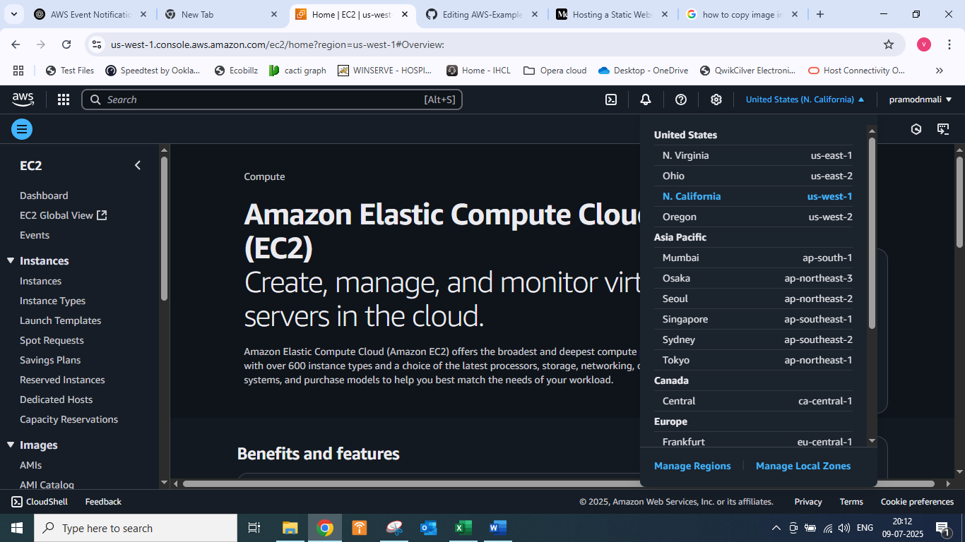
# Launch an EC2 Instance
- # # Search for “EC2” in the AWS Management Console and select it.
- Click “Launch Instance.”
- Give your EC2 instance a name.
- Choose Amazon Linux 2 as the Amazon Machine Image.
- Select t2.micro as the instance type.
- Create a new key pair and choose the .pem format.
- Select your key pair and the security group you created.
- Launch the instance and wait for it to pass the status check.
# 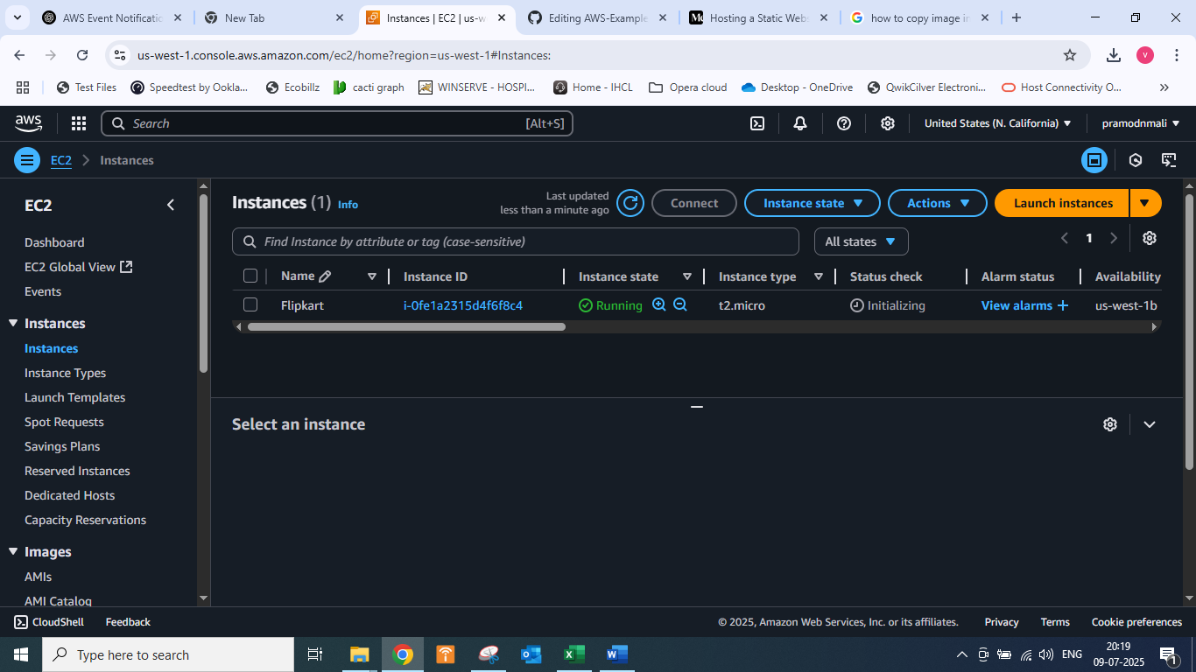
# SSH into the Instance
- ## Copy the public IPv4 address of the EC2 instance from the details section.
- Use an SSH client to connect to the instance by pasting the SSH command in your terminal or GitBash, replacing “FPT-key.pem” with the correct path and the IPv4 address.
- Type “yes” to continue when prompted.
# 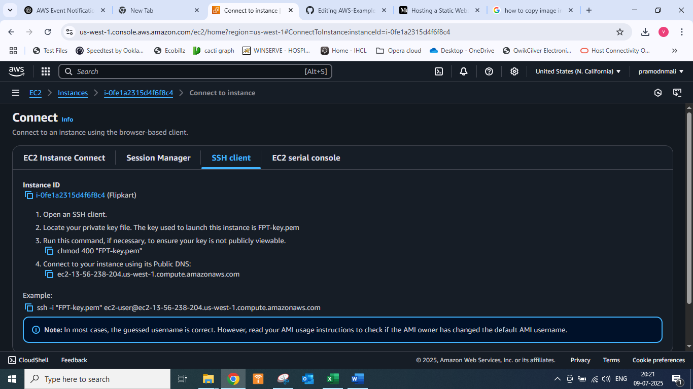
# #
# Install Required Software
- Once logged into the instance, become the root user using the command “sudo -i.”
- Update the instance with “yum update -y.”
- Yum install httpd -y
- Systemctl start httpd
- Systemctl enable httpd
- Systemctl status httpd
- Cd /var/www/html
# Have to create index.html file with the help of vim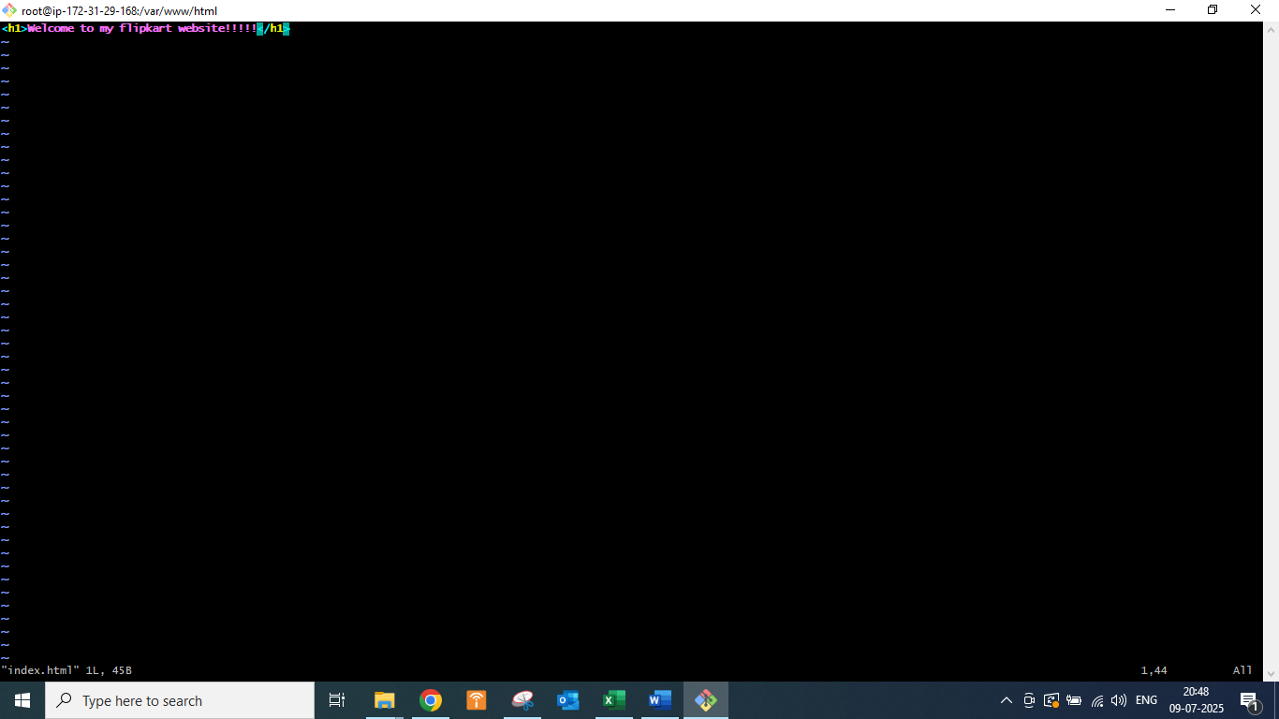
## In that file enter I to insert text
## Write a header line and press Esc button and :wq to exit this file
# Access Your Static Website
- Copy the public IPv4 address of the instance.
- Paste the address in your browser’s new tab.
- Your static website is now live and accessible!
# 

